



[](http://www.aintreehospital.nhs.uk/)

**Liverpool Breast Service**

Dear Colleague

This is to inform you about important changes to the **Breast 2ww pathway** and documentation.

The clinics endeavour to see all patients within a two week waiting time target, whether they are referred on a suspected cancer pathway, or the symptomatic but non-urgent pathway. To date the current 2ww forms have made little differentiation between these two groups, and equally there has been little differentiation between male and female patients even though the presenting issues are very different. As a result patients can face delays or extra visits and associated stress.

In order to provide your patients with the best care, we require your support as far as your referrals are concerned so that we can see the appropriate patients and provide the excellent service that is expected from our department. We have therefore introduced important changes to the 2ww forms for breast cancer:

* Introducing **RED** boxes for where the referral is query cancer and **BLUE** boxes where the issue is more around symptomatic disease.
* We have also developed a separate form for male patients which includes the requirement for key blood tests pre referral as benign gynaecomastia is by far the commonest condition males are referred to the clinic with.

The referral forms are available on your clinical system; and referrals are to be made via ERS.

During the review that has led to these changes, referrals into the units have been reviewed to understand key issues faced by General Practitioners. This has provided some useful learning as the variation amongst GPs in terms of reason for referrals is significant, which has also been built into the forms. Key points are -

* Breast pain, without lumps, should initially be given reassurance and advice about the management of breast pain. **Most cases of breast pain presenting to our clinic are in fact musculoskeletal in origin**, therefore 6-8 weeks of non-steroidal anti-inflammatory treatment (usually topical for the massage benefits) would be appropriate and effectiveness evaluated before the decision to refer to the breast clinic. **Breast pain alone is not an indication for imaging**. Reassure the patient that breast pain alone is very rarely associated with any significant pathology (a recent local audit of patients with breast pain did not detect any breast cancers). Given that so many cases we see are musculoskeletal in origin it is also worth considering checking vitamin D levels and supplement as necessary. Useful leaflets can be found on the breast cancer care website <https://www.breastcancercare.org.uk/benign-breast-conditions>
* Eczematous conditions should be managed with topical steroids and then evaluated. If the condition is **involving the nipple or areola**, and does not settle with topical treatment, then a referral can be made to the breast clinic. If nipple/areola not involved, then a referral to dermatology may be more appropriate.

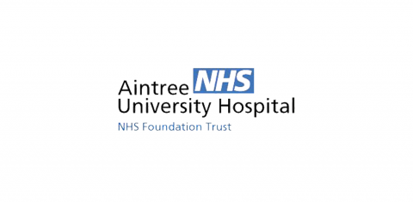 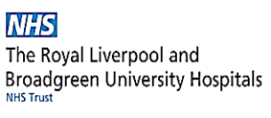

**Liverpool Breast Service**

* Other conditions like gynaecomastia should initially be investigated with relevant blood tests if required or the cause looked for in their medications and social practices before a referral is made. There are only 350 cases of male breast cancer diagnosed per year in England (versus 50,000 in women), and significantly less than 1% of male referrals turn out to have cancer.  Often reassurance and time is all that is required – see <https://patient.info/doctor/gynaecomastia> for more information and  possible non surgical treatments
* Referrals for cosmetic procedures, such as breast reduction, should be made via the CCG Criteria Based Clinical Treatment process. Breast augmentation is not available on the NHS.
* Referrals for any other reasons such as, but not limited to:
  + new prostheses (Breast care nurse secretary)

Aintree 0151 529 4082

Royal 0151 706 3778

* Transfer of care

Aintree 0151 529 4967/8

Royal 0151 706 2959/2255

* Post-cancer treatment problems can be made by the patient to their breast care nurse:
* Aintree 0151 529 4082
* Royal 0151 706 2927
* Family history
* Aintree - Separate referral route on ERS
* Royal - Fax: 0151 706 2901

As noted on the 2ww forms if you are unsure about a referral we would welcome a conversation. Please use Advice and Guidance, which we check on a daily basis.

Thank you for your assistance. These measures will significantly help our patients receive a more streamlined appropriate service, especially those with possible cancer.

Yours sincerely,

**Mr Lee Martin Ms Geraldine Mitchell**

Consultant Breast Surgeon Consultant Breast Surgeon

Aintree Hospital Royal Liverpool Hospital